

Garrick Cox, MD, Robert M. Masella, MD Ryan Dowling, MD , Robin Gehrmann, MD

Gary J. Drillings, MD MBA

Kristin C. Riley, PA-C • Michael Gerne, PA-C

246 Hamburg Turnpike, Suite 301/302, Wayne, NJ 07470 Office 973-689-6266 • Fax 973-689-6264 • [www.njog.com](http://www.njog.com/)

Patient Information PLEASE PRINT

TODAY’S DATE: / /

Last Name:

First Name:

Middle:

Email: Marital Status: Married Single Divorced Separated Widowed

Sex: M F Date of Birth: / /

Age:

Social Security #: - -

Street Address: Apt./Floor:

City:

State:

ZIP Code:

Home Phone: ( ) -

Cell Phone: ( ) -

Work Phone: ( ) -

Occupation: Employer:

Employer Address: Driver’s License #:

Primary Care Physician:

Pharmacy Name:

Insurance Information PLEASE GIVE INSURANCE CARD TO RECEPTIONIST

Phone: ( ) -

Phone: ( ) -

Type of Insurance: Worker’s Comp. • MVA

Other *(please specify)*:_

Subscriber Name: Subscriber’s DOB: / /

Primary Insurance ID #: Group #:

Patient’s Relationship to Subscriber: • Self • Spouse Child Other:

Secondary Insurance ID #: Group #:

Patient’s Relationship to Subscriber: • Self • Spouse Child Other:

# In Case of Emergency Contact

Name of Relative or Friend:

Name of Relative or Friend:

Phone: ( ) -

Phone: ( ) -

*The above information is true to the best of my knowledge. I authorize Garrick Cox, MD, to provide myself or my child with reasonable and proper medical care according to today’s standards. I authorize the insurance company or any third party payer to pay any benefits due directly to this office should they accept assignment on my claims. I understand that Garrick Cox, MD, has the right to refuse or accept AOB. If I receive any payment from my insurance carrier relating to any services rendered, I agree to hold such payment in trust for Garrick Cox, MD, and I agree to send such payment to Garrick Cox, MD, within one week after I receive same. I UNDERSTAND THAT I AM FINANCIALLY RESPONSIBLE FOR THE ACCOUNT EVEN THOUGH INSURANCE MAY BE PENDING ON ALL OR A PORTION OF THE CHARGES.*

X _

*Patient/Guardian Signature*

Date: / /

# Purpose of Your Consult/Visit



Was injury/pain a result of an accident? Yes No If Yes, Job Related Auto Other: What is the condition for which you are seeking medical attention?

Site of injury (which body part): Side: Right Left Date of injury or onset: / / Having pain s ince: / /

ATTORNEY INFORMATION *(if applicable)*

Name: Phone: ( ) - Fax: ( ) - Describe the events of the injury/accident/pain:

Have you previously been treated for this or a similar condition? Yes No

If yes, what was the treatment?

What were the results of the treatment?

List any previous major injuries/surgeries:

Have you had any diagnostic tests related to condition *(i.e., x-ray, MRI, CT, EMG)*? Yes No

If yes, please list:

PLEASE GIVE ANY REPORTS/RESULTS OF TESTING TO RECEPTIONIST

*I hereby authorize the release of medical information necessary to process my insurance claim. This may include intake forms, chart notes, reports, correspondences, billing statements and any other information to my attorneys, health care providers and insurance case managers. I have stated all medical conditions that I am aware of and will keep my practitioner informed of any changes.*

*X Date: / /*

*Patient/Guardian Signature*

Personal History PLEASE PRINT

|  |  |  |  |
| --- | --- | --- | --- |
| *Have You Had?* | ./  *YES* | *Family History*  *(list family member)* | *Please list any surgeries related to disorder/injury* |
| Recurrent Headaches |  |  |  |
| Bone Injuries/Fractures |  |  | *Body Part(s):* |
| Joint Injuries *(i.e., Arthritis, Carpal Tunnel)* |  |  | *Body Part(s):* |
| Epilepsy/Seizures |  |  |  |
| Cancer |  |  | *Type of cancer(s):* |
| Thyroid Disorder |  |  |  |
| Heart Murmur |  |  |  |
| Angina |  |  |  |
| Congestive Heart Failure |  |  |  |
| Heart Disease |  |  |  |
| Heart Arrhythmia |  |  |  |
| Heart Stents |  |  |  |
| Diabetes |  |  | *Type I Type II* |
| High Blood Pressure |  |  |  |
| High Cholesterol |  |  |  |
| Anemia |  |  |  |
| Sickle Cell |  |  |  |
| Bleeding Disorders |  |  |  |
| Hepatitis |  |  | *Type A Type B* |
| Kidney/Liver Disorders |  |  | *Type of disorder:* |
| Lupus |  |  |  |
| Alcohol/Drug Abuse |  |  | *How often? How long?* |
| Lyme Disease |  |  |  |
| Tuberculosis |  |  |  |
| Gout |  |  |  |
| Asthma/Emphysema |  |  |  |
| Other: |  |  |  |

Do you smoke? • Yes • No If Yes, how many packs per day? Are you allergic to Latex? Yes No

For how many years have you been a smoker?

If Yes, what is the reaction? • Redness • Swelling • Rash Hives • Other: List any medications that you are allergic to: If Yes, what is the reaction? • Redness • Swelling • Rash • Hives Other: List any medication(s) you are currently taking:

# HIPAA Compliant Authorization for the Release of Patient Information

PURSUANT TO 45 CFR 164.508

TO:

*Name of Healthcare Provider/Physician/Facility/Medicare Contractor*

Street Address: Apt./Floor:

City:

State:

ZIP Code:

RE: Patient Name:

Date of Birth: / / Social Security #: - -

*I authorize and request the disclosure of all protected information for the purpose of review and evaluation in connection with a legal claim. I expressly request that the designated record custodian of all covered entities under HIPAA identified above disclose full and complete protected medical information including the following:*

* All medical records, meaning every page in my record, including but not limited to: office notes, face sheets, history and physical, consultation notes, inpatient, outpatient and emergency room treatment, all clinical charts, reports, order sheets, progress notes, nurses’ notes, social worker records, clinic records, treatment plans, admission records, discharge summaries, requests for and reports of consultations, documents, correspondence, test results, statements, questionnaires/ histories, correspondence, photographs, videotapes, telephone messages, and records received by other medical providers.
* All physical, occupational and rehab requests, consultations and progress notes.
* All disability, Medicaid or Medicare records including claim forms and record of denial of benefits.
* All employment, personnel or wage records.
* All autopsy, laboratory, histology, cytology, pathology, immunohistochemistry records and specimens; radiology records and films including CT scan, MRI, MRA, EMG, bone scan, myleogram; nerve conduction study, echocardiogram and cardiac catheterization results, videos/CDs/films/reels and reports.
* All pharmacy/prescription records including NDC numbers and drug information handouts/monographs.
* All billing records including all statements, insurance claim forms, itemized bills, and records of billing to third party payers and payment or denial of benefits for the period / / to / / .

*I understand the information to be released or disclosed may include information relating to sexually transmitted diseases, acquired immunodeficiency syndrome (AIDS), or human immunodeficiency virus (HIV), and alcohol and drug abuse. I authorize the release or disclosure of this type of information.*

*This authorization is given in compliance with the federal consent requirements for release of alcohol or substance abuse records of 42 CFR 2.31, the restrictions of which have been specifically considered and expressly waived.*

*You are authorized to release the above records to the following representatives of defendants in the above-entitled matter who have agreed to pay reasonable charges made by you to supply copies of such records:*

Name of Representative:

Representative Capacity *(e.g. attorney, records requestor, agent, etc.)*: _

Street Address: Apt./Floor:

City:

State:

ZIP Code:

*I understand the following: See CFR §164.508(c) (2) (i-iii)*

X _

*Patient Signature*

X _

*Signature of Legal Representative*

Date: / /

Date: / /

# Acknowledgement of Receipt of Notice of Privacy Practices

We keep record of the healthcare services we provide for you. You may ask to see and copy that record. You may also ask us to correct that record. We will not reveal your records to others unless you direct us to do so or unless the law authorizes or tells us to do so. You may see your record or get more information about it by contacting our office’s Practice Administrator/Manager.

Our notice of Privacy Practices describes in more detail how your health information may be used and revealed, and how you can obtain your information.

YOU MAY REFUSE TO SIGN THIS ACKNOWLEDGMENT

*I, , received a copy of the Office's Notice of Privacy Practice.*

X _

*Patient/Guardian Signature*

Date: / /

We attempted to obtain written acknowledgement of receipt of our Notice of Privacy Practice, but acknowledgement could not be obtained because:

Individual refused to sign

* An emergency situation prevented us from obtaining acknowledgement

Other

X _

*Employee Signature*

Date: / /

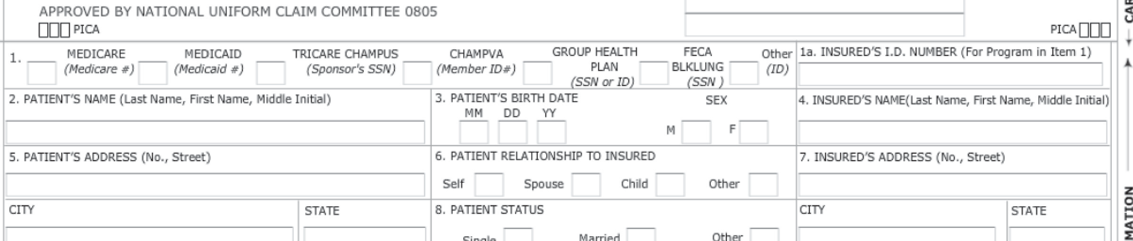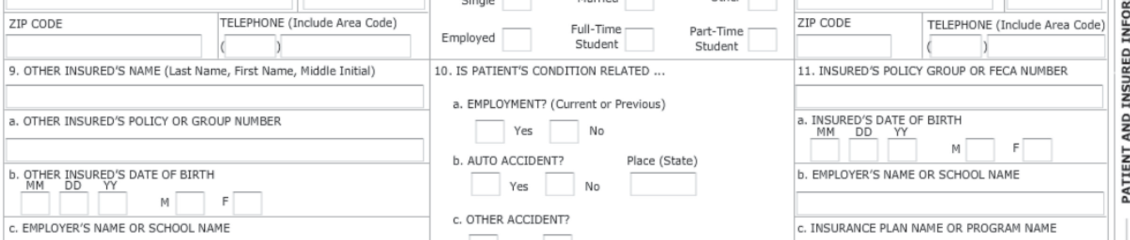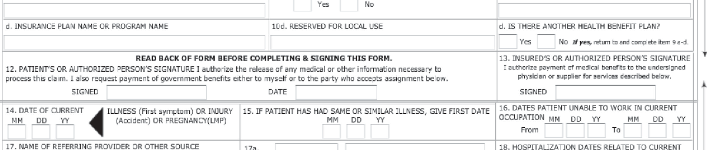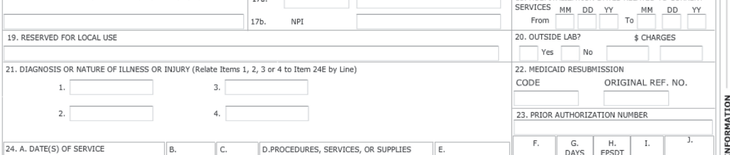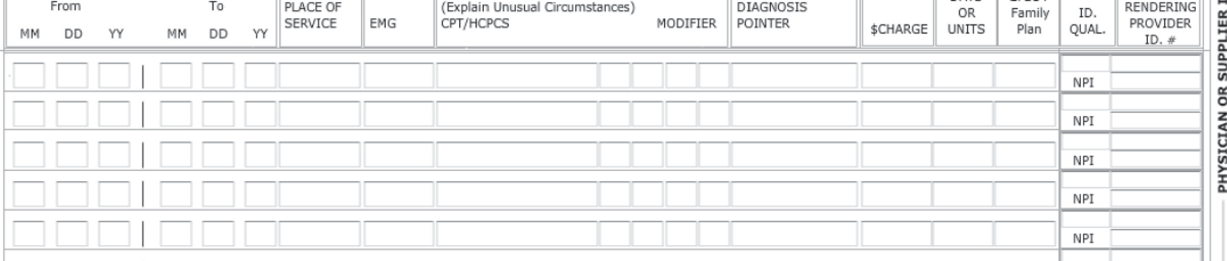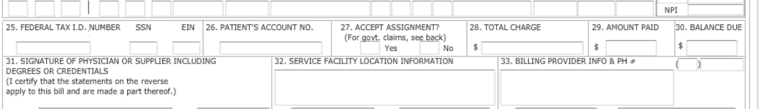

# Assignment of Benefits

Patient Name:____________________________________________________________________________________________

Street Address: Apt./Floor:

City:

Date of Loss *(accident if applies)*: / /

State:

ZIP Code:

Insurance Company:

Name of Policyholder:

Policy #: Claim #:

1. *I, the undersigned, hereafter referred to as “the patient,” do hereby assign all of my rights and interests to Garrick Cox, MD, hereafter referred to as “Medical Provider” to pursue and obtain payment from the above-mentioned insurance carrier. This assignment shall include, but is not limited to, all rights available to me pursuant to the Personal Injury Protection Statues of the State of New Jersey. In addition, I appoint the Medical Provider as my Designated Authorized Representative and will sign a separate authorization which will be provided to my insurance carrier. Should my insurance carrier require additional forms relating to this designation, I agree to sign them and return the originals to the Medical Provider’s office.*
2. *I, the patient, do hereby acknowledge that I have an obligation to comply with reasonable requests made of me by the insurance carrier. I, the patient, do further agree to cooperate with the attorney selected by the Medical Provider.*
3. *For any balances owed by me, not covered by my insurance policy, or monies not turned over that are paid directly to me, I agree to pay an attorney’s collection fee equal to 33 1/3% of the outstanding balance, plus court and related costs, in the event my account is turned over to an attorney for collection.*
4. *I, the patient, do hereby understand and acknowledge that if l willfully refuse to comply with reasonable requests of the insurance carrier, payment of my medical bills may be denied and I will be held responsible for same.*
5. *I, the patient, authorized my bodily injury attorney and/or insurance carrier to pay directly to the Medical Provider any monies due on my account, and will direct my attorney to provide the Medical Provider with a letter of protection against any settlement that is made on my behalf.*
6. *I, the patient, do hereby acknowledge that I will not file suit and/or arbitration for the payment of the above Medical Provider’s medical bills. I agree to have the Medical Provider’s attorney represent me (or my child) if legal action is necessary to collect from my insurance carrier. I waive any conflict of interest that may exist between me and the Medical Provider.*
7. *The Medical Provider will comply with the decision point review request as required by the plan.*
8. *The Medical Provider shall submit disputes to personal injury protection dispute arbitration if the decision point review plan requires same.*
9. *In the event it is determined by an Arbitrator and/or Court of Law that the imposition of a copayment penalty was as a result of the Medical Provider’s failure to pre-certify treatment or comply with other decision point review requirements the provider will hold the patient harmless for such copayment penalty.*

X _

*Patient/Guardian Signature*

Date: / /

Patient Name *(print)*: _

# Legal Assignment of Benefits

& Designation of Authorized Representative

I, , represent that I have valid and in-force insurance and/or employee health care benefits coverage, and hereby assign and convey directly to Garrick Cox, MD (the “provider(s)”), as my Statutory Derivative Beneficiary (SDB), commonly known as an Designated Authorized Representative, and a Claimant under the “Patient Protection and Affordable Care Act” (PPACA), existing ERISA and other applicable federal and state laws, all medical benefits and/or insurance reimbursement, if any, otherwise payable to me for services rendered from the provider(s), regardless of the provider’s managed care network participation status. I understand that I am financially responsible for all charges regardless of any applicable insurance or benefit payments. I hereby authorize the provider(s) to release all medical information necessary to process my claims under HIPAA. I hereby authorize any plan administrator or fiduciary, insurer and my attorney to release to the provider(s) any and all plan documents, insurance policy and/or settlement information upon written request from the provider(s) in order to claim such medical benefits, reimbursement or any applicable remedies. I authorize the use of this signature on all my insurance and/or employee health benefits claim submissions.

I hereby convey to the provider(s), to the full extent permissible under the law and under any applicable employee group health plan(s), insurance policies or liability claim, any claim, chose in action, or other right I may have to such group health plans, health insurance issuers or tortfeasor insurer(s) under any applicable insurance policies, employee benefits plan(s) or public policies with respect to medical expenses incurred as a result of the medical services I received from the provider(s), and to the full extent permissible under the law to claim or lien such medical benefits, settlement, insurance reimbursement and any applicable remedies, including, but not limited to, (1) obtaining information about the claim to the same extent as the assignor; (2) submitting evidence; (3) making statements about facts or law; (4) making any request, or giving, or receiving any notice about appeal proceedings; and (5) any administrative and judicial actions by the provider(s) to pursue such claim, chose in action or right against any liable party or employee group health plan(s), including, if necessary, to bring suit by the provider(s) against any such liable party or employee group health plan in my name with derivative standing but at such provider(s) expenses. Unless revoked, this assignment is valid for all administrative and judicial reviews under PPACA, ERISA, Medicare and applicable federal or state laws. A photocopy of this assignment is to be considered as valid as the original. I have read and fully understand this agreement.

X _

*Signature of Insured/Guardian*

Date: / /

Name of Insured/Guardian *(print)*: _

DATE: / /

# Certified Letter, Return Receipt Requested

Attn: Plan Administrator

RE: Request for Summary Plan Description (SPD) & 5500 Form

Patient Name: Insured Name: Date of Service: / /

Plan #:

Insured ID:

Dear Plan Administrator:

I hereby request from you a complete copy of the governing plan documents, a written explanation of how level of benefit payments are determined for out-of-network providers, the Summary Plan Description (SPD) & the 5500 Form (Plan Annual Return). For the purpose of the applicability of compliance with PPACA, we specifically request a certified copy of your Certificate for PPACA Grandfathered Health Plan. In absence of such a certificate, you are statutorily required to comply with all provisions of PPACA and ERISA claim regulations.

Please provide to me c/o Garrick Cox, MD, 246 Hamburg Turnpike, Ste. 301/302, Wayne, New Jersey, 07470, as soon as possible, but no later than 30 days from the date of this letter, the requested SPD and 5500 Form. A statutory SPD penalty of up to $110 per day for each day beyond 30 days may apply for failure to timely provide us with the requested information.

If the governing plan or SPD has any specific procedures and provisions on how to designate an authorized representative or how to verify plan participants designees, please provide us with such specific plan provisions within five business days in order for us to comply with the plan’s requirements.

Sincerely,

X _

*Patient/Guardian Signature*

Date: / /

Patient Name *(print)*: _

Encls. Legal Assignment of Benefits/ Authorized Representative